Kinetic titration (1:1 interaction)
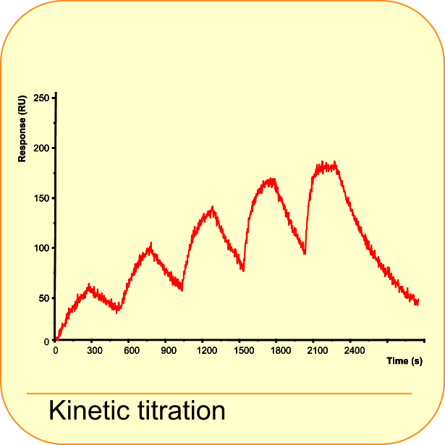
The kinetic titration (single cycle kinetics) is useful with interactions which are difficult to regenerate or when regeneration is detrimental to the ligand (1). In addition, it can be used to determine the concentration and kinetic range of an interaction. During the kinetic titration, the analyte is injected from a low to high concentration with short dissociation times in between and a long dissociation time at the end. The short and long dissociation times will speed up the injection sequence. If the interaction is strong, regeneration is added at the end. The sequential analyte injections with only one regeneration at the end, greatly reduces experimental time (3).
All the analyte injections are analysed in the same sensorgram with a special equation for kinetic titration. The model is based on the one to one binding interaction and is limited to five analyte injections (2). A mass transfer component (kt) and drift are added in de model.
It is assumed that the flow in the cell is sufficiently high so that there is no depletion or accumulation of analyte in solution, that the analyte concentration remains constant during the association phase, that the analyte concentration is zero and there is no analyte rebinding during the dissociation phase.

Reaction equation
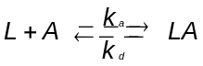

Differential equations
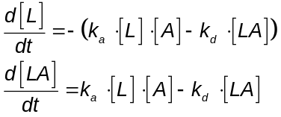
[A] = C_{analyte}
[L]₀ = R_{max}
[LA]₀ = 0
Parameters
[L] = concentration of free ligand in RU
[A] = concentration of free analyte in M
[LA] = concentration of ligand-analyte complex in RU
k_{a} = association rate constant in M⁻¹ s⁻¹
k_{d} = dissociation rate constant in s⁻¹
Because it is not possible to solve this type of injection with the simultaneous fitting of k_{a} and k_{d} models, a numeric model is used.
Numeric model
LA + RI1*$1 + RI2*$2 + RI3*$3 + RI4*$4 + RI5*$5 + Drift*(t-ton1));
L = ligand
A = analyte
LA = complex
kt = mass transport coefficient
Conc = highest analyte concentration
F = dilution factor
c_time = contact time analyte
ton1 = start time of injection 1
RI1 = refractive index response of injection 1
$1=(sign(t-(ton1))-sign(t-(ton1+c_time)))/2;
$2=(sign(t-(ton2))-sign(t-(ton2+c_time)))/2;
$3=(sign(t-(ton3))-sign(t-(ton3+c_time)))/2;
$4=(sign(t-(ton4))-sign(t-(ton4+c_time)))/2;
$5=(sign(t-(ton5))-sign(t-(ton5+c_time)))/2;
$6=kt* ($1*conc/(Fˆ4) + $2*conc/(Fˆ3) + $3*conc/ (Fˆ2) + $4*conc/(F) + $5*conc-A);
$7=ka*L*A - kd*LA;
A=$6–$7|0;
L=-$7|Rmax;
LA=$7|0;

Setup of the model in BiaEvaluation
Parameters
Name | Fit | Allow Neg. | Keyword | Initial value | Units
ka | Global | No | No | 1e5 | M⁻¹s⁻¹
kd | Global | No | No | 1e-3 | s⁻¹
Rmax | Local | No | No | YMax | RU
kt | Global | No | No | 2e7 | RU M⁻¹ s⁻¹
RI1* | Local | Yes | No | 0 | RU
RI2* | Local | Yes | No | 0 | RU
RI3* | Local | Yes | No | 0 | RU
RI4* | Local | Yes | No | 0 | RU
RI5* | Local | Yes | No | 0 | RU
Conc | No | No | Yes |  | M
ton1 | No | No | Yes |  | s
ton2 | No | No | Yes |  | s
ton3 | No | No | Yes |  | s
ton4 | No | No | Yes |  | s
ton5 | No | No | Yes |  | s
c_time | No | No | Yes |  | s
F | No | No | Yes
Drift* | Local | Yes | No | 0 | RU s⁻¹

*) Although in the parameter table the RI and Drift are locally fit, they are in the model set to a constant of zero. It is better to start to fit the curves without these parameters. When the kinetic parameters are known, then it is possible to add refractive index bulk effect or drift.

Report
Name | Value | Units
ka | ka | M⁻¹s⁻¹
kd | kd | s⁻¹
KD | kd/ka | M
Rmax | Rmax | RU
kt | kt | RU M⁻¹ s⁻¹
RI1 | RI1 | RU
RI2 | RI2 | RU
RI3 | RI3 | RU
RI4 | RI4 | RU
RI5 | RI5 | RU
Drift | Drift | RU s⁻¹

Response
R = R_{LA} + R₀ + R_{I} + Drift

Download zip-file
Explanation document Kinetic titration.pdf
Numeric model Kinetic titration models.pdf and *.mdl
Example data Kinetic titration 1.txt
Kinetic titration 2.txt
Example data Kinetic titration.ble

Example data:
Concentrations: 10, 20, 40, 80, 160 nM

References

1. Dougan, D. A. et al; Effects of substitutions in the binding surface of an antibody on antigen affinity. Protein Eng (11): 65-74; 1998.
2. Karlsson, R. et al; Analyzing a kinetic titration series using affinity biosensors. Anal.Biochem. (349): 136-147; 2006.
3. Palau, William and Di Primo, Carmelo; Simulated single-cycle kinetics improves the design of surface plasmon resonance assays. Talanta (114): 211-216; 2013.

